Common Shot and Common Offset

Seismic Surveys

Amelia Campos

Department of Earth, Planetary, and Space Sciences

University of California, Los Angeles

595 Charles E Young Dr., Los Angeles, CA 90095

**INTRODUCTION**

A common shot gather is a collection of seismic signals obtained by repeatedly generating signals at one location while varying the location of the receiver. A common offset gather requires the source and receiver to remain a specified distance apart while both are moved along the survey line. Both a common shot and common offset survey were conducted to determine subsurface layer geometry at a site in Lakewood, California.

**SURVEY SITE**

The survey site is a 100-meter line on a small area of grass located just outside of the Lakewood Tennis Center. The starting point was located at (33.835805 $°$, -118.154576 $°$) and the ending point at (33.835773 $°$, -118.153420 $°$).

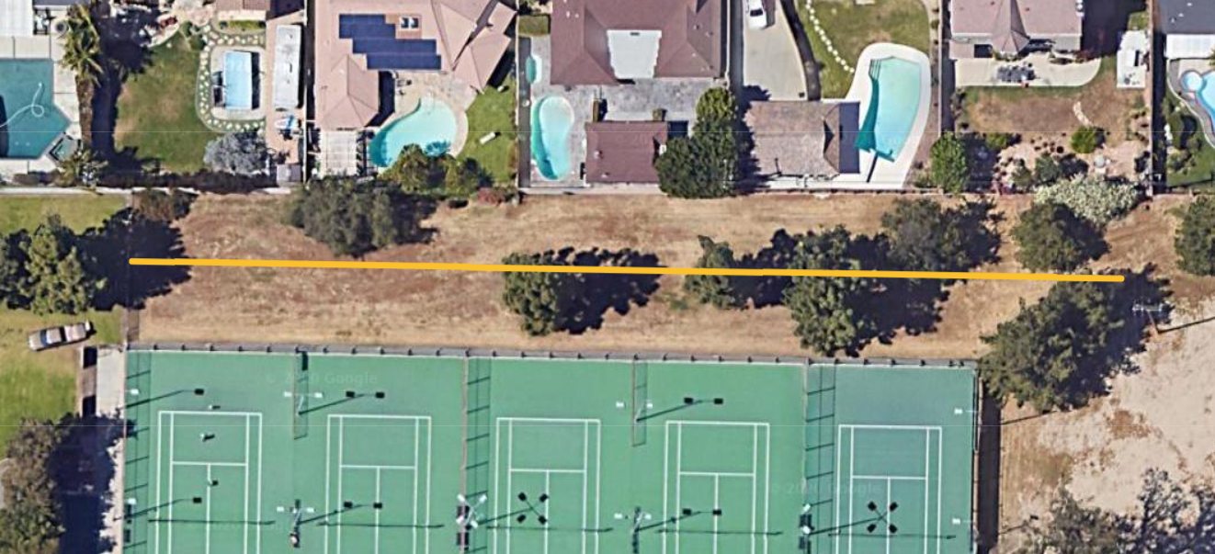

**INSTRUMENTATION**

The seismic waves were generated by pounding a sledgehammer into an aluminum plate. They were detected by two geophones: a “trigger” geophone, placed next to the plate; and a “roving” geophone, located along the survey line at a distance from the plate. The Focusrite Scarlett 2i2 audio interface was used to record the waves.

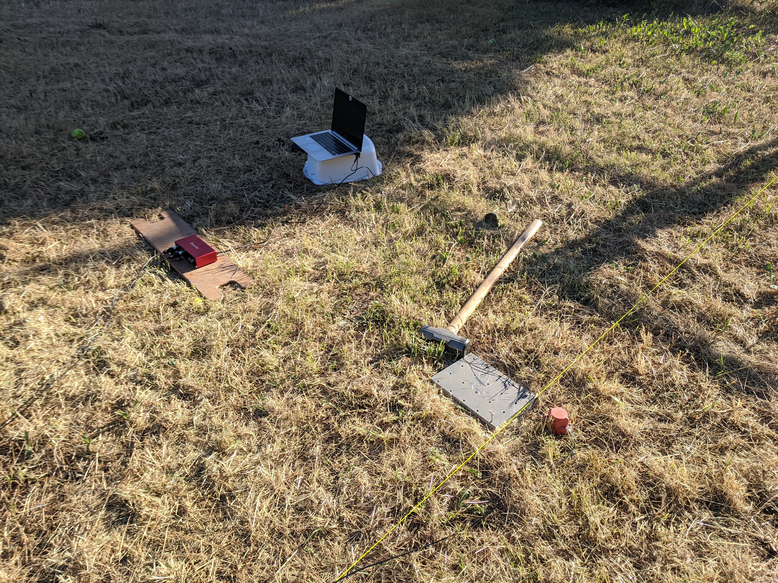

**Common shot survey**

**PROCEDURE**

Setup: A 100-meter line is marked off with string attached to stakes. At the start of the line, the trigger geophone is placed next to the aluminum plate and the roving geophone starts at 2 meters along the line from the plate for the first shot. The roving geophone is then moved 2 meters down the line for every shot. The signals are recorded for 5 seconds. After each shot, a plot of the signals is checked to ensure that (1) the trigger signal looks consistent, and (2) the rover signal is decreasing, but still visible over any noise. The gain on the Scarlett is also increased to keep the signal at about 0.5 of the maximum as the geophone moves farther away.

Trigger detection: To locate the first trigger peak, an algorithm compares peaks and finds the first one that is greater than *rise* = 0.0003. For my data, the trigger detection worked when keeping the *baseline* = 4 and *goback* = 3. I changed the polarity to positive so that the first peak was increasing.

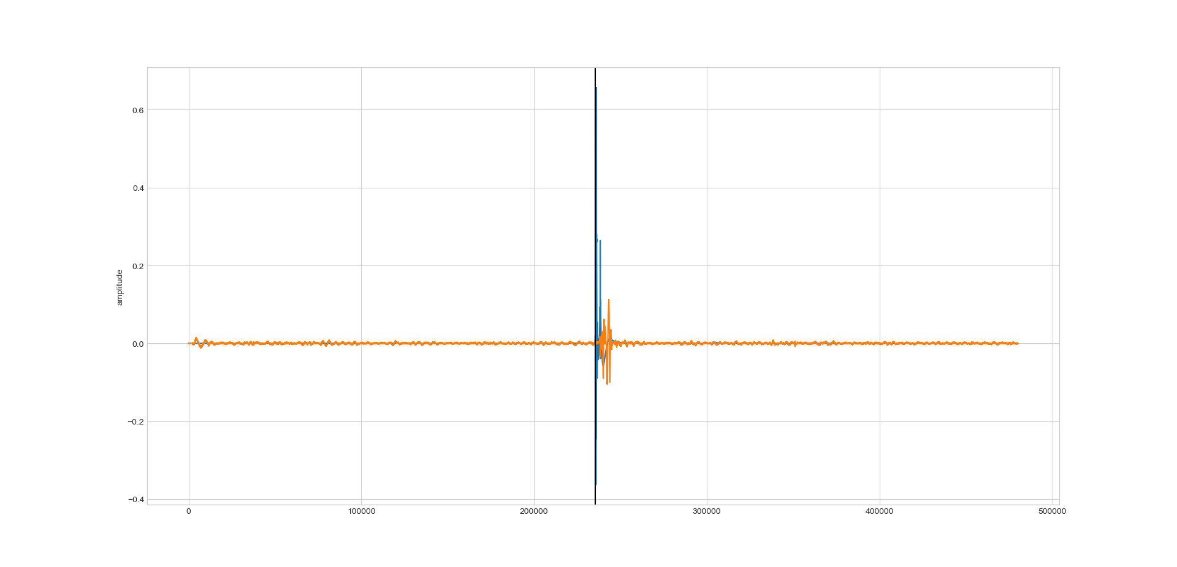

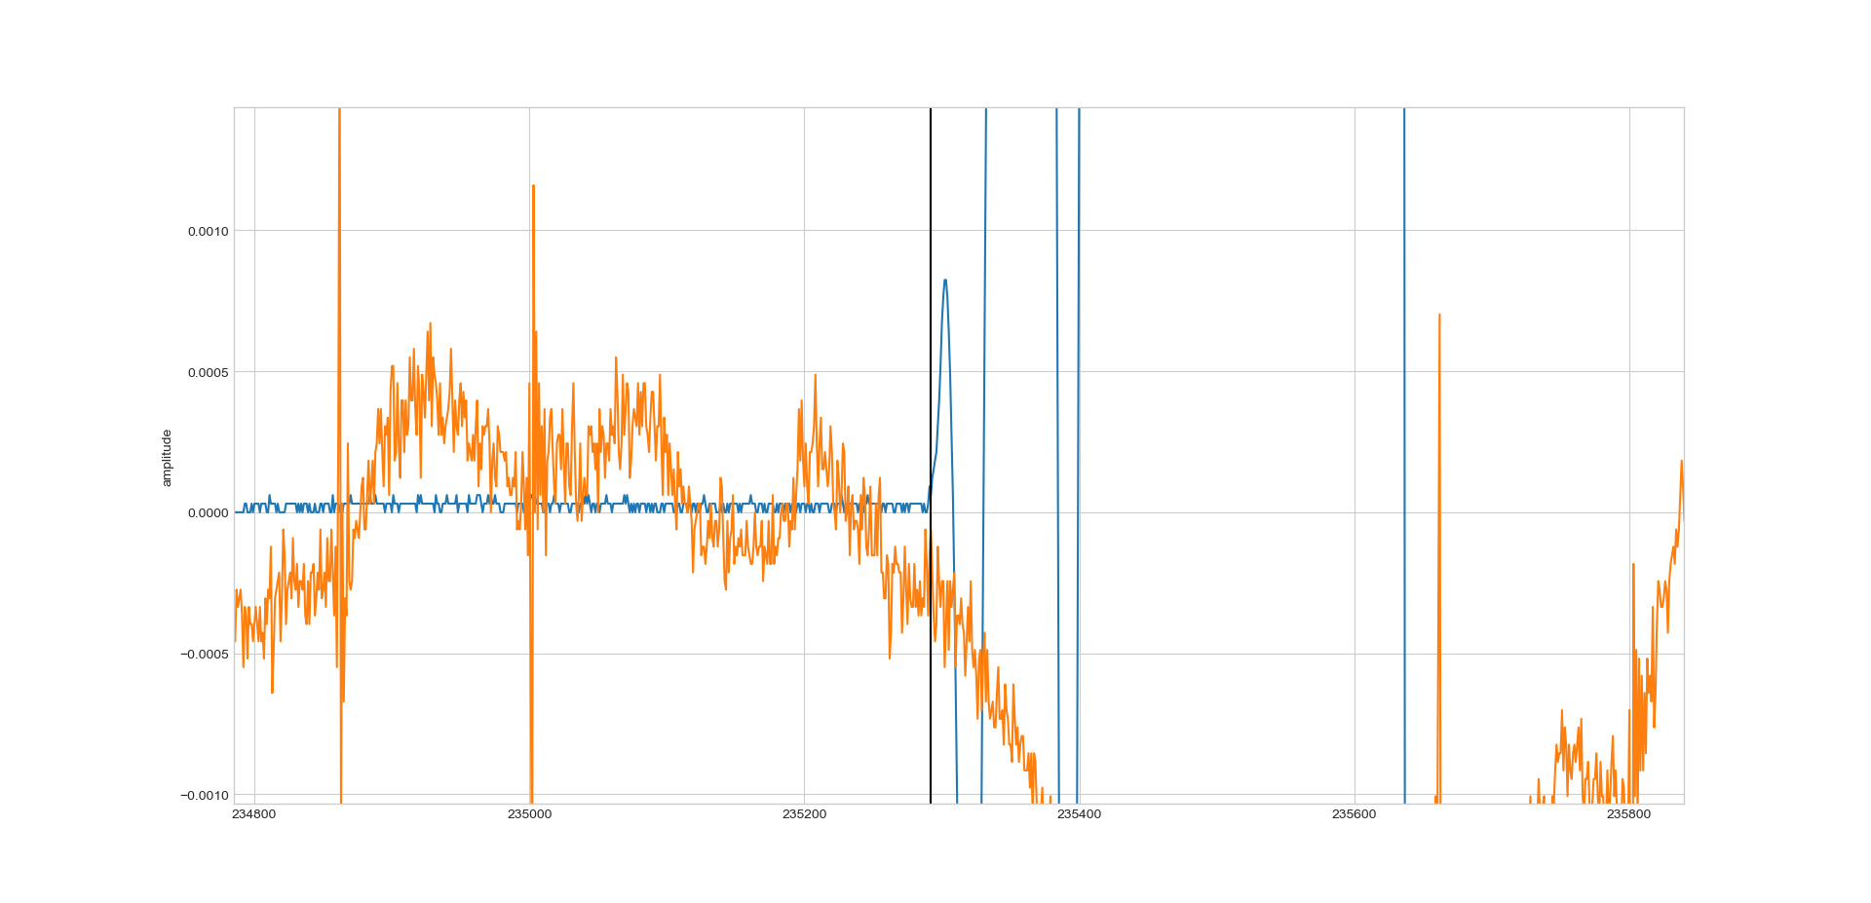

Figure 1 Checking the trigger. (a) The blue peaks are the trigger geophone signal and the orange peaks are the rover signal. The maximum trigger peak has an amplitude of 0.6. (b) Close-up of first peak with positive polarity.

**RESULTS**

**Signal Filtering**

Figure 4 shows the frequency power plots of the signals from shots 0, 15, and 28. To be able to see the waves more clearly in the time-distance curves, the data must be normalized and noise filtered out. The high-pass filter removes data below 10 Hz, while the low-pass filter removes frequencies above 100 Hz. The high-pass filter preserves shot 28, but clips the signals for the other two shots. As there is a lot of high-frequency noise, the low-pass filter preserves all three shots the best. The remaining low-frequency noise can be removed by instead using a band-pass filter.

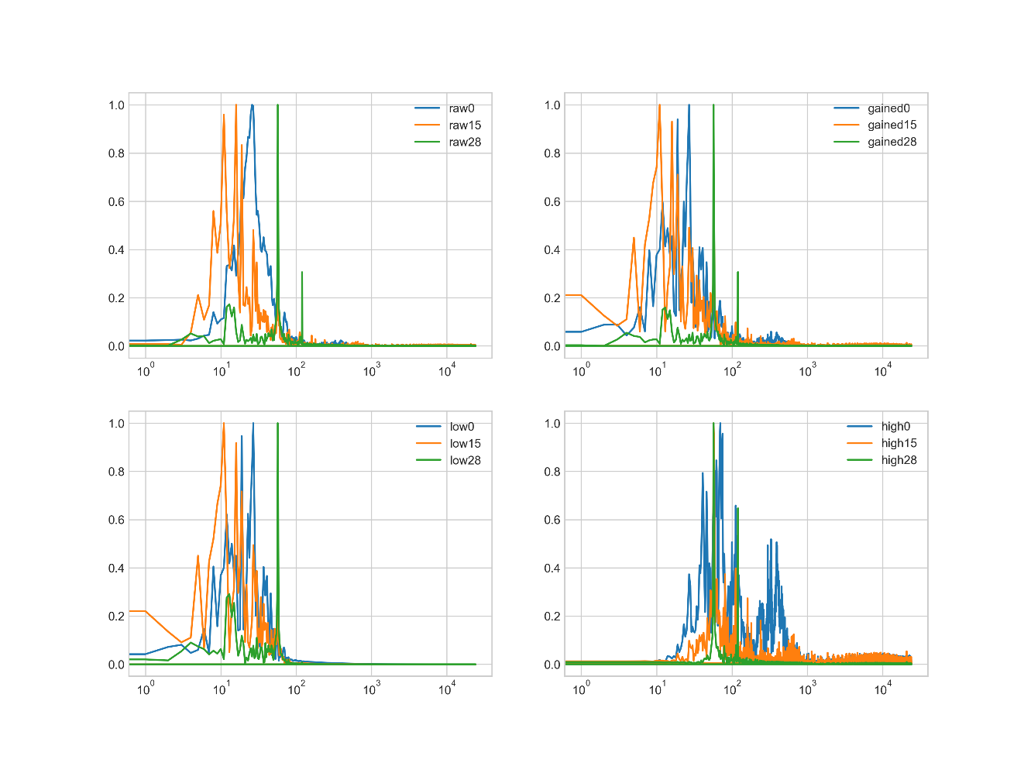

$$Amplitude$$

$$Frequency$$

Figure 2 Frequency spectra of gained, low, and high-pass filtered shots compared to the original data.

**Time-distance plots**

Figures 3-8 show time as a function of the distance from the source, before and after filtering. The band-pass filter is most effective at producing clear waves, but the low-pass data are also fairly readable. This aligns with the observations made on the frequency plots because there is more noise in the higher frequency region. Accordingly, the gain and high-pass filters are not effective at making all the waves visible.

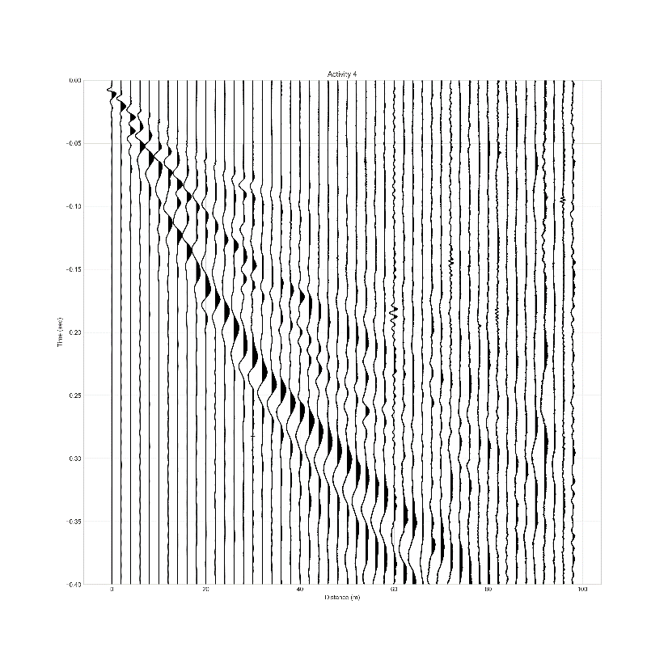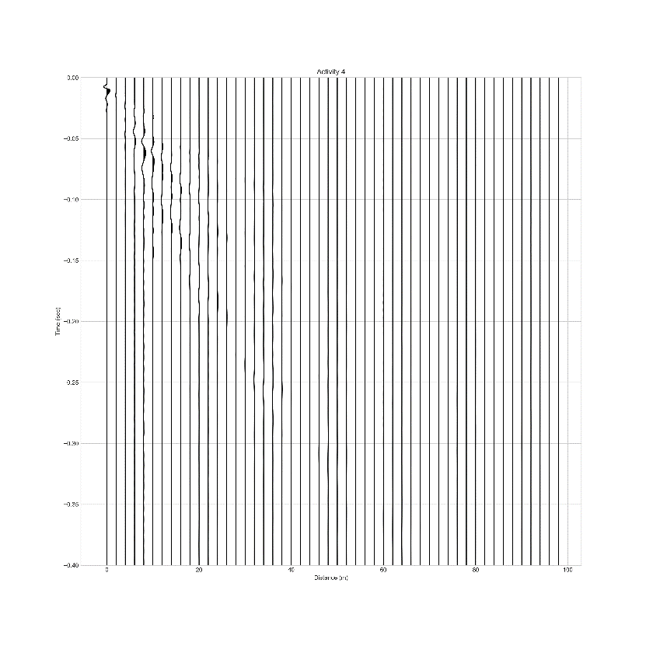

Figure 3 Unfiltered data.

Figure 4 Normalized data. The reflection wave and ground roll are visible, but the refraction wave and air roll are not clear.

$$Distance (m)$$

$$Time (s)$$

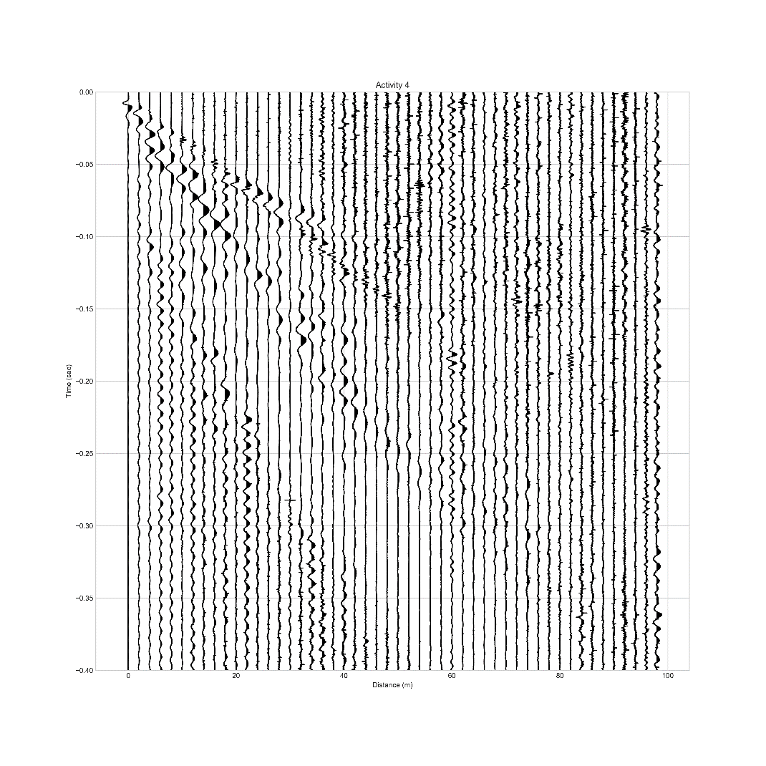

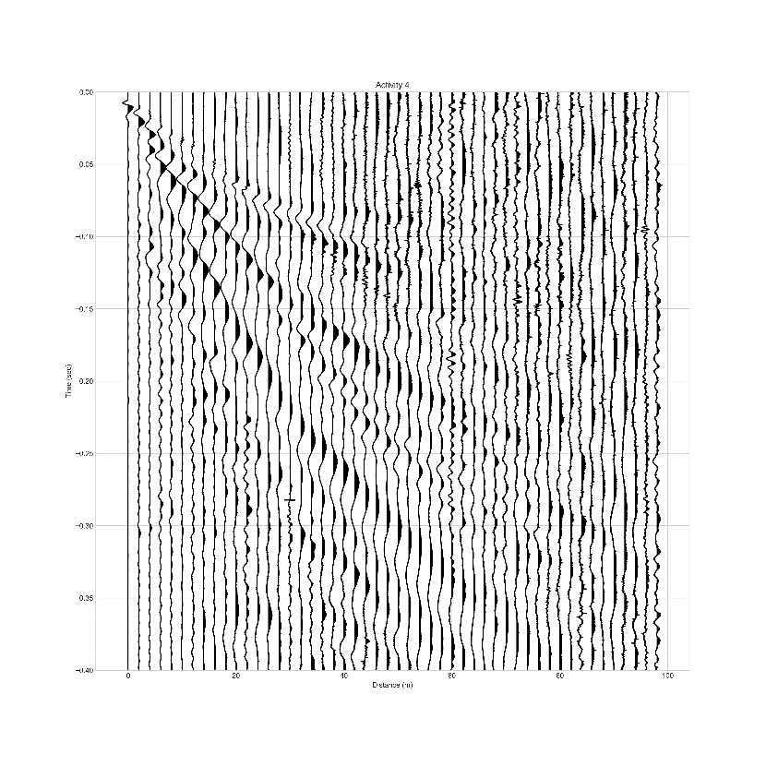

$$Time (s)$$

Figure 5 Data with gain applied. Refraction, reflection, air, and ground roll waves are all visible.

$$Distance (m)$$

Figure 6 Data with high-pass filter applied. Data below 10 Hz are removed. The reflection and ground roll waves are just barely visible.

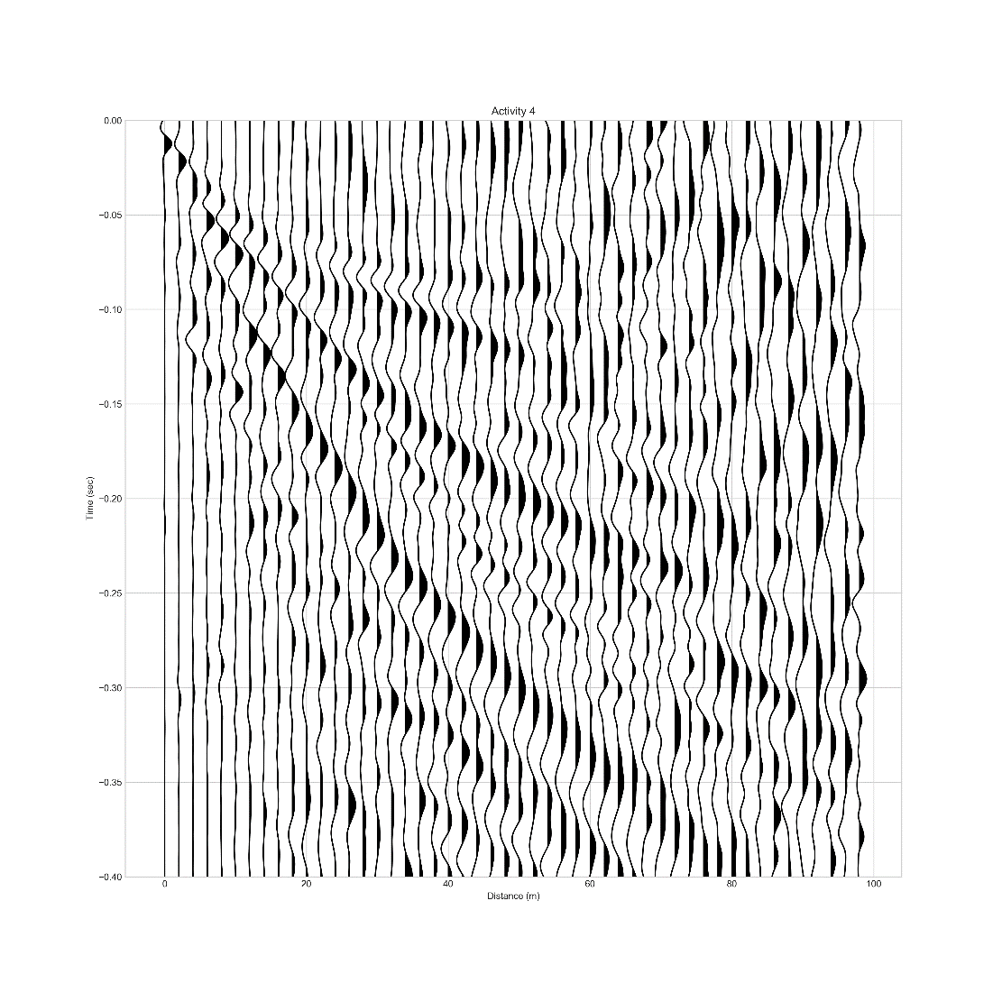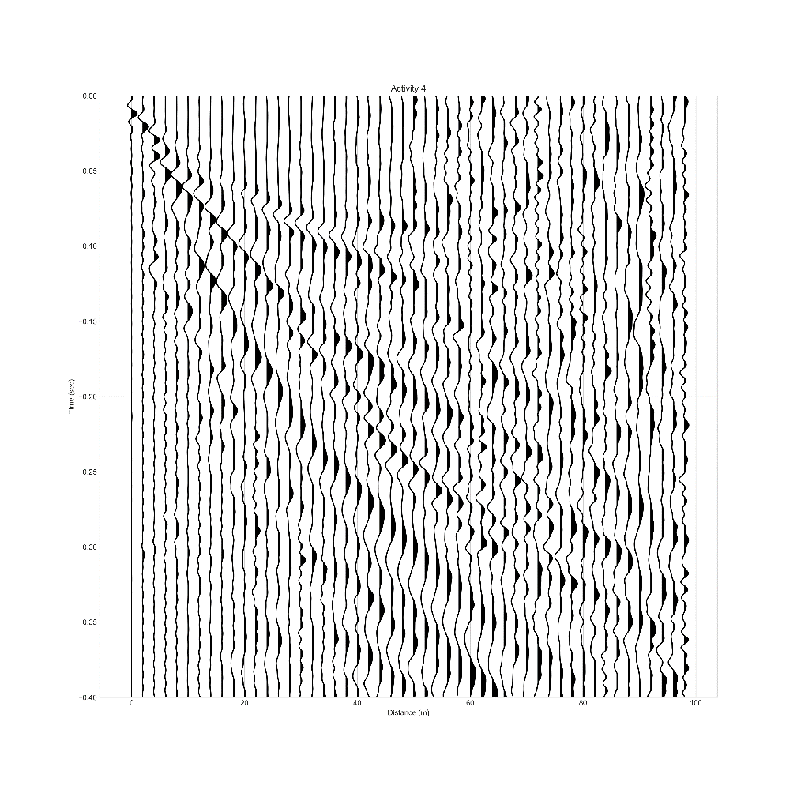

$$Distance (m)$$

$$Time (s)$$

Figure 8 Band-pass filter. Data outside of 10-120 Hz is removed. The waves appear similar to the gained filter, but more detail is visible. Most importantly, smaller waves such as the refraction wave can be seen.

Figure 7 Low-pass filter. Data above 100 Hz are removed. All four waves are clear, but some noise is amplified, which is exemplified in the top right corner.

**Modeling a cross-section**

The next step is to locate the ground roll, reflection, refraction, and air waves (Figure 9). The ground roll spans the entire diagonal of the plot, starting at the origin, because it travels along the shortest path. As it is a Rayleigh-type surface wave, it will also likely have the lowest velocity and thus the steepest slope in the time-distance plot.

The reflection curve is hyperbolic due to an increase in the wave velocity as it travels through shallower, less dense material on its way toward the surface.

Critically refracted waves travel along the layer interface at the velocity of the denser medium. Because they have a longer path to travel, after a certain distance from the source they will arrive at the surface before the reflections. With increasing distance, they will similarly outpace all other waves that travel at the upper layer’s velocity. This appears on the time-distance plot as the wave with the shortest arrival time for distances past this cross-over distance. The presence of only one reflection wave and one refraction wave implies a two-layer subsurface.

The upper layer’s velocity is the inverse slope of the wave that travels the minimum distance (the ground roll). Because the refracted wave travels parallel to the surface at the second layer’s velocity, the distance between two waves’ length of travel along the interface is the same as the distance between the points where they reach the surface. Thus, if a surface travel distance of a refracted wave is known, then the interface travel distance is known. This means the second layer’s velocity is simply obtained via the inverse slope of the refracted wave.

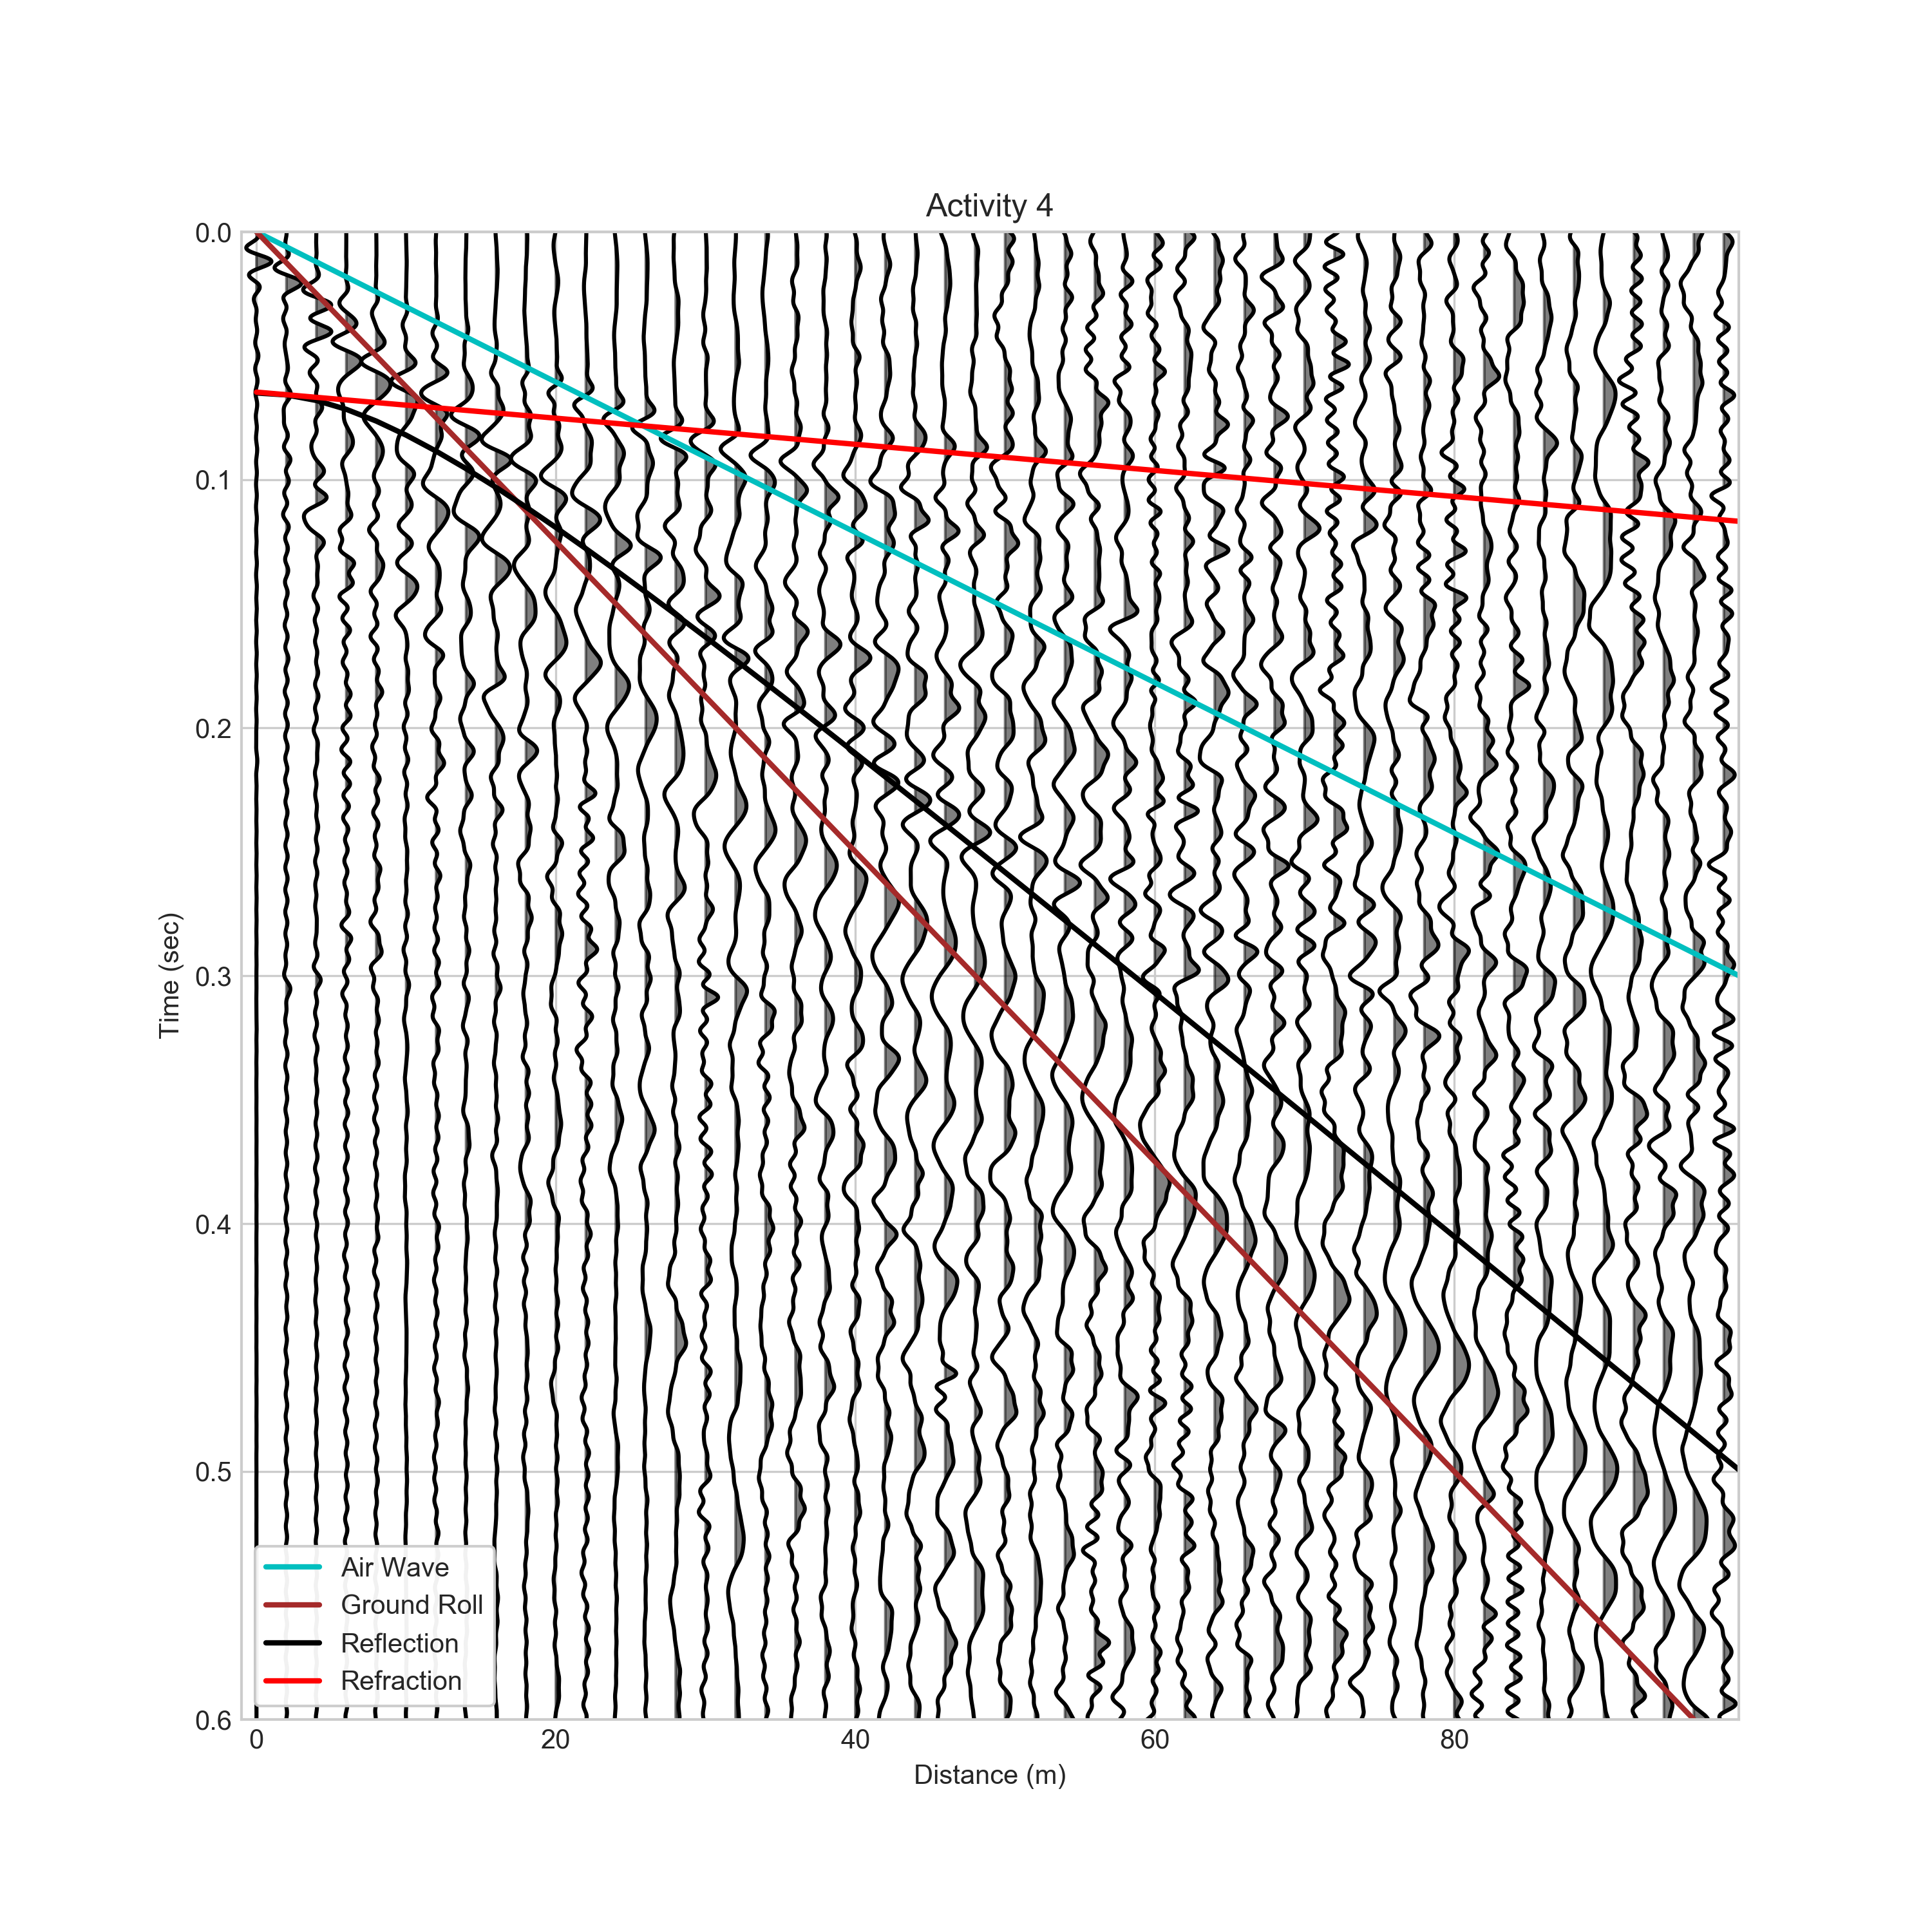

$$Time (s)$$

$$Distance (m)$$

Figure 9 Waves indicating a two-layer structure. The traces are shown with the band-pass filter applied.

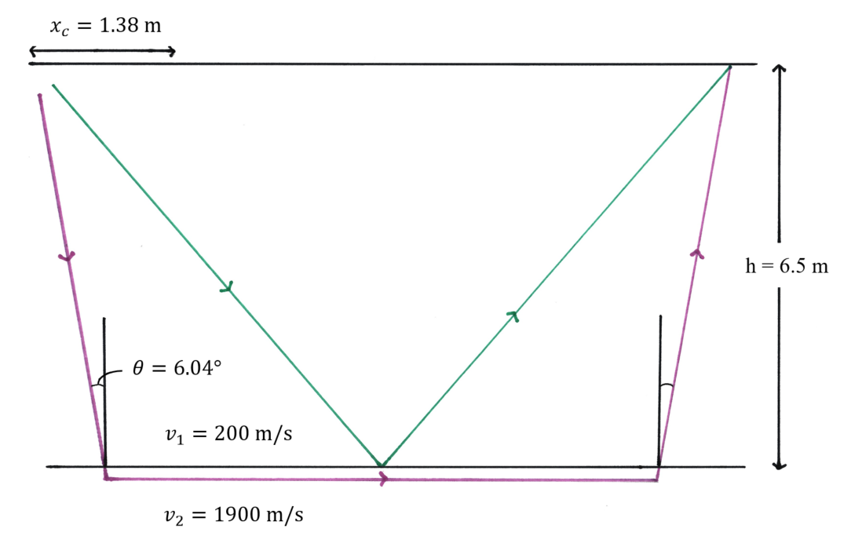

Figure 10 Cross section based on common shot survey.

The calculated values required to make a cross-section (Figure 10) are:

Layer 1 velocity: 200 m/s

Layer 2 velocity: 1900 m/s

Layer 1 depth: 6.50 m

Critical angle: 6.04 $°$

Critical distance: 1.38 m

The small velocity of the first layer indicates a weak material, likely soil, which aligns with what would be expected at the survey site. The velocity in the next layer is nearly ten times as fast as in the first layer, indicating denser material such as wet sand or clay.

**Common offset survey**

**PROCEDURE**

The 100-meter line, Scarlett interface, and trigger geophone are set up as in the previous survey. The plate starts at the 2-meter mark for the first shot and moves 2 meters down the line for each subsequent shot. The roving geophone starts at an offset distance of 22 meters, and moves 2 meters along with the trigger after every shot. The common offset distance was chosen by locating the smallest distance at which the reflection and refraction waves could be seen clearly in Figure 9. The gain on the Scarlett interface is adjusted as before.

**RESULTS**

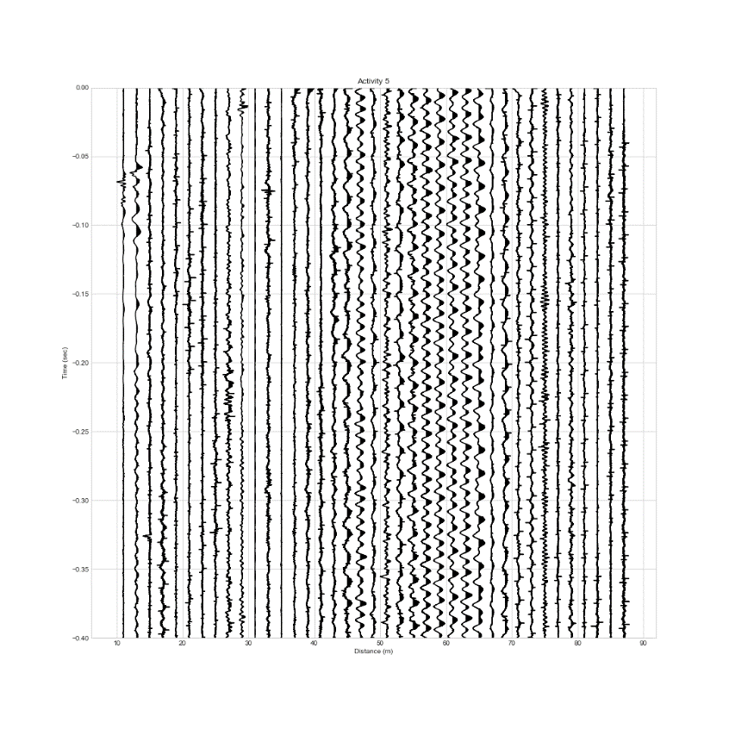**Time-distance plots**

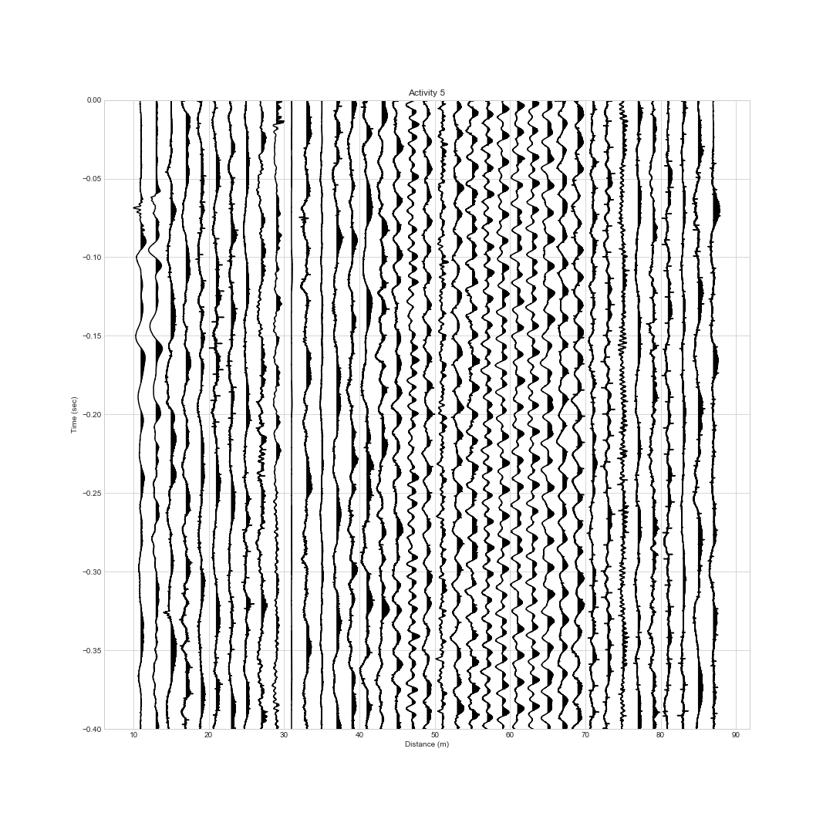

Figure 12 High-pass filter. Data below 10 Hz are removed.

Figure 11 Common offset gather plot with gain.

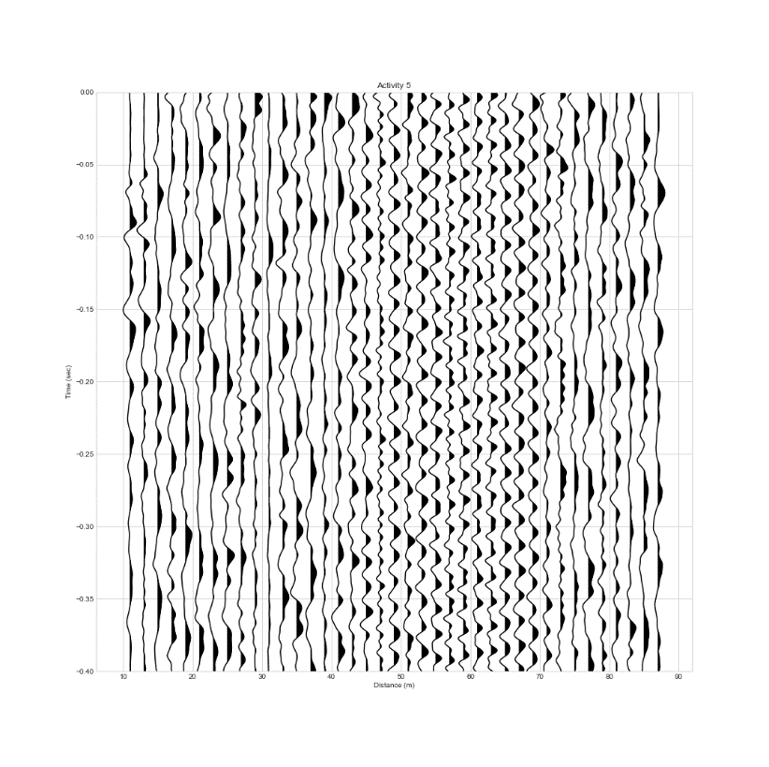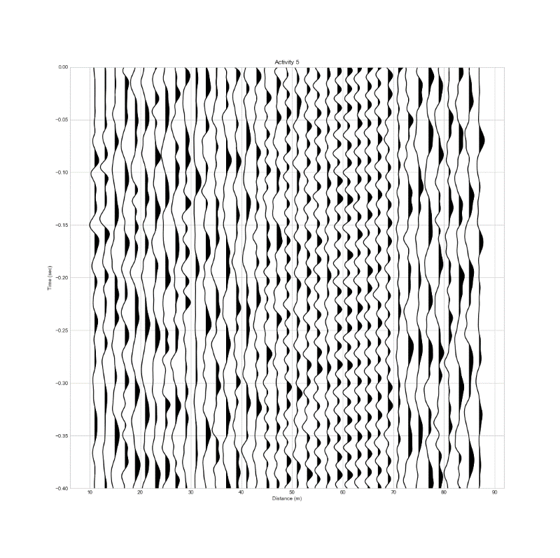

$$Time (s)$$

$$Distance (m)$$

Figure 14 Band-pass filter. Data outside of 10-120 Hz are removed.

Figure 13 Low-pass filter. Data above 100 Hz are removed.

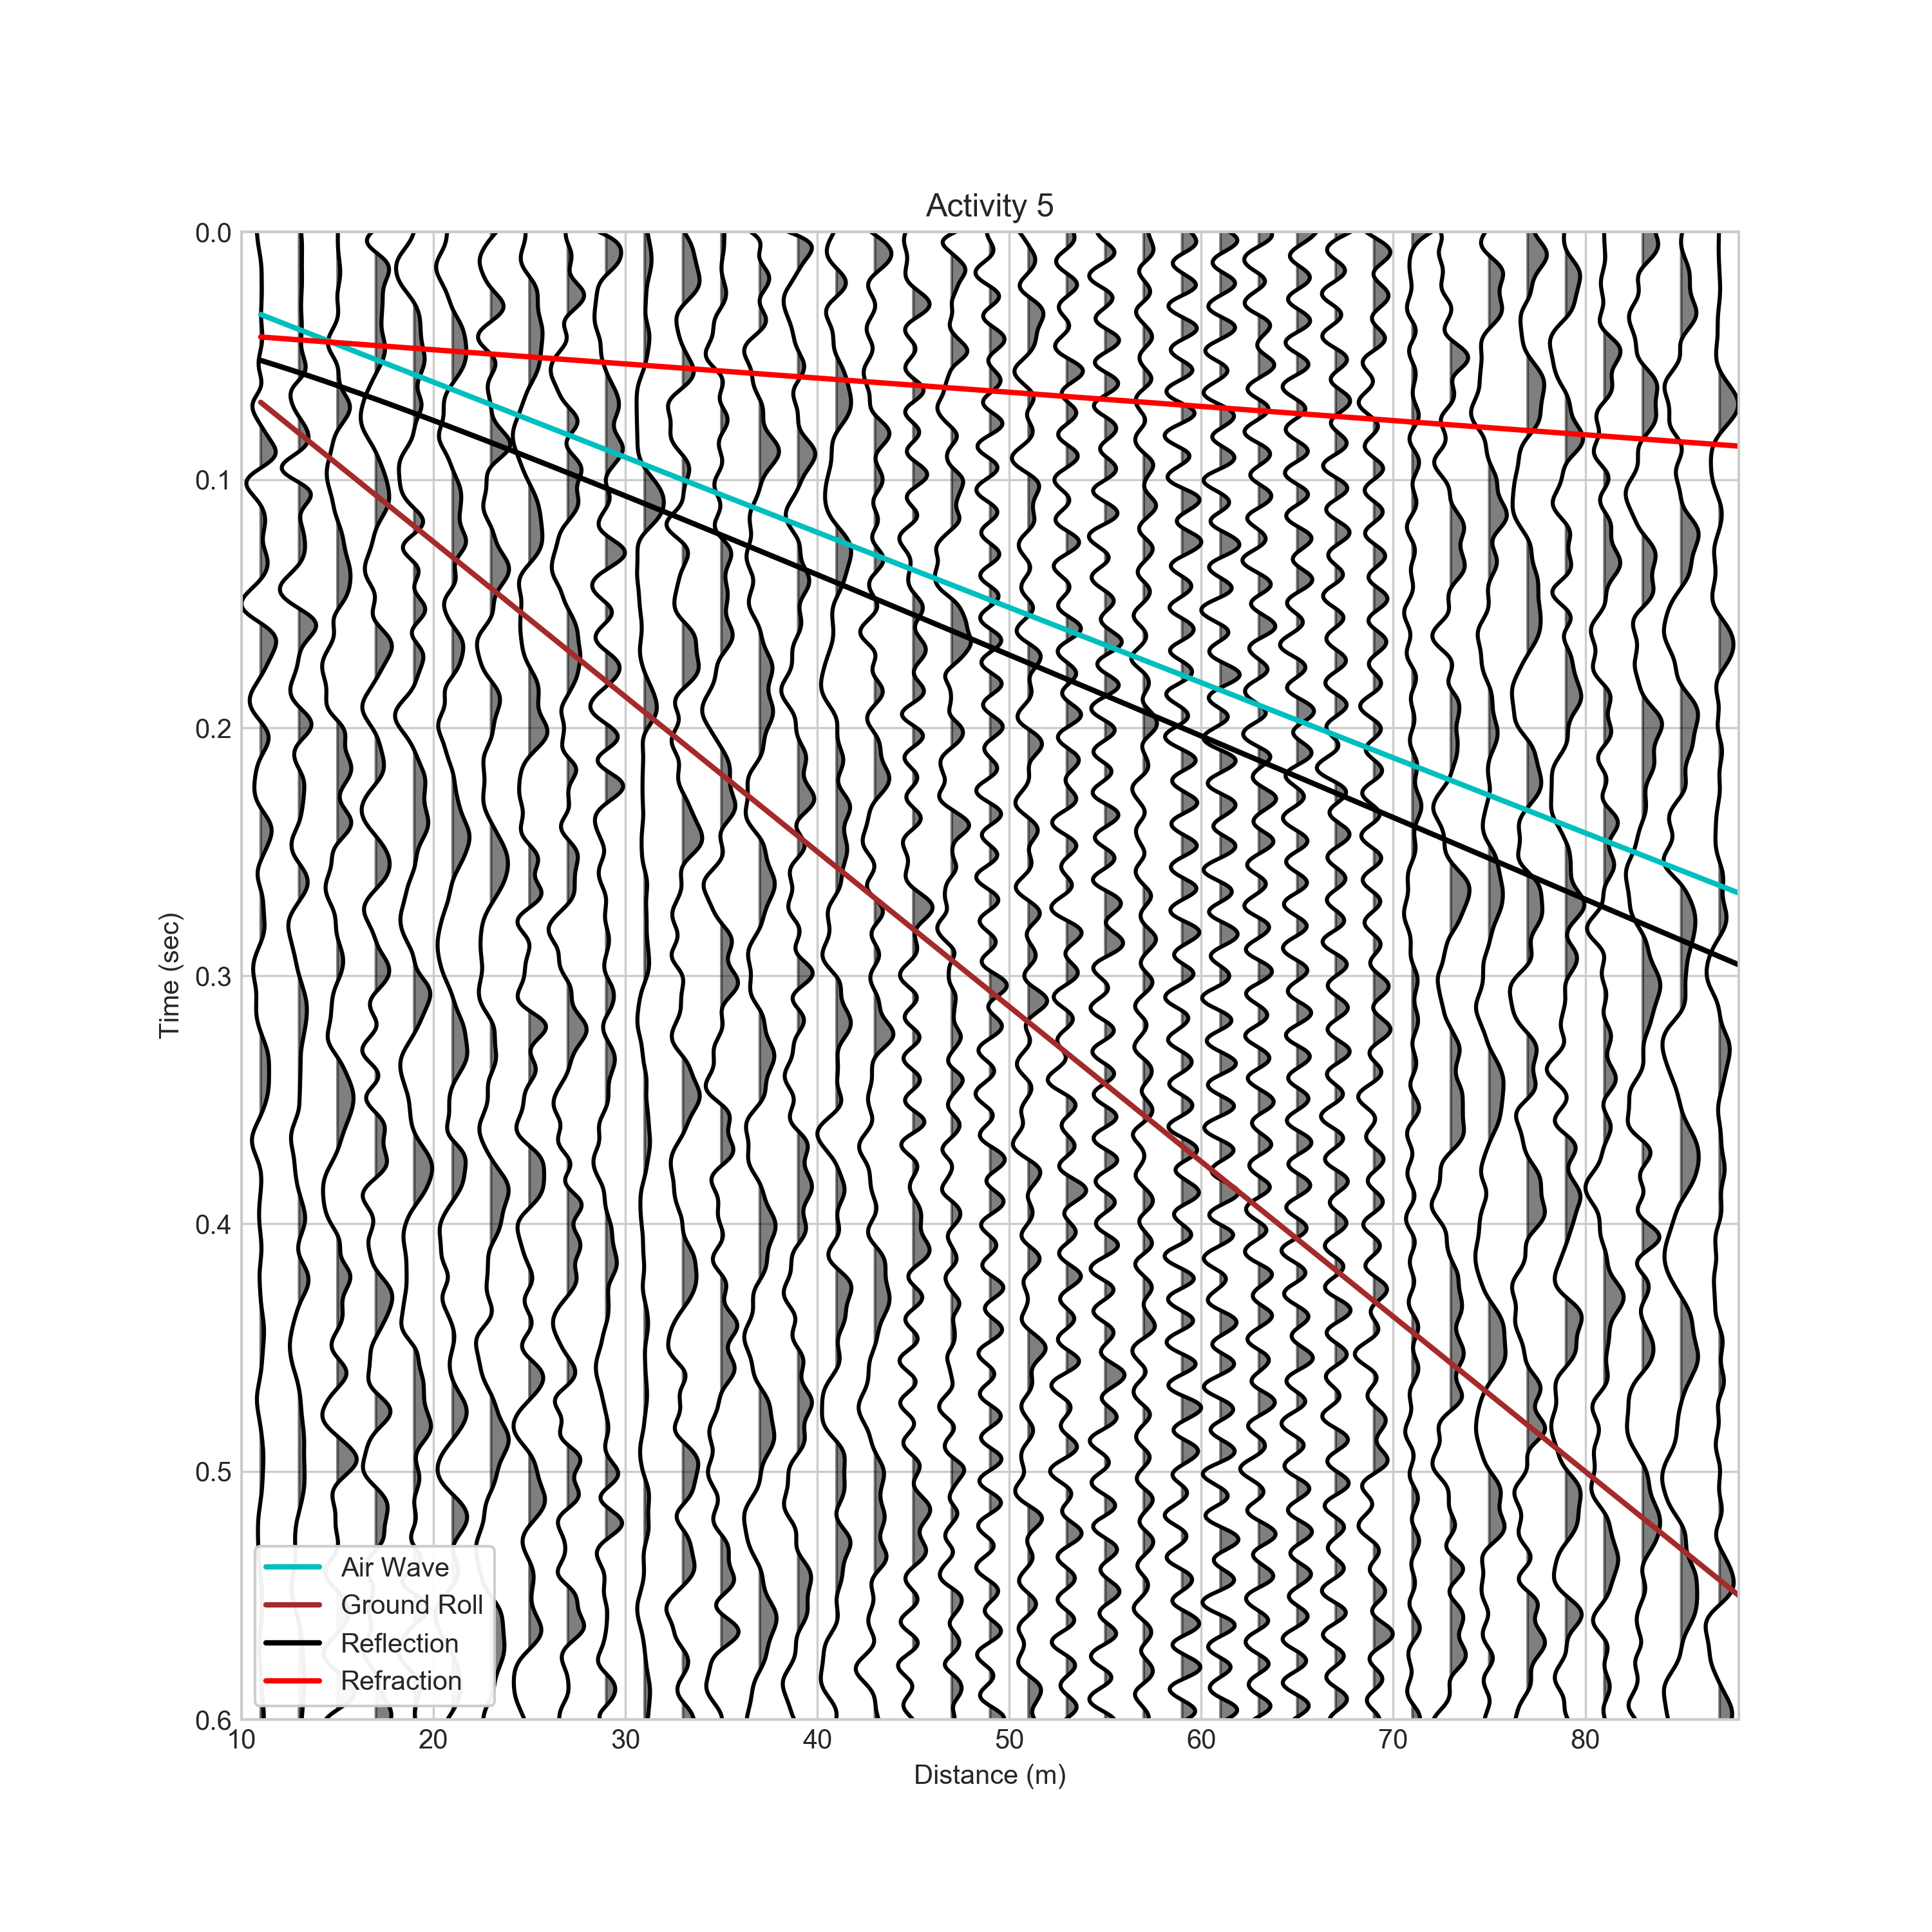

$$Time (s)$$

$$Distance (m)$$

**Modeling a cross-section**

Figure 15 Two Layer model results for the common offset survey. The data are shown with the band-pass filter.

The strip of noise within the 44-64 meter range is immediately apparent, possibly due to external factors occurring at the time these data were taken. Since all of the signals were particularly noisy, I could only make an attempt at finding the reflection and refraction waves. Using these estimates, the layer results were:

Layer 1 velocity: 300 m/s

Layer 2 velocity: 1750 m/s

Layer 1 depth: 5.50 m

Critical angle: 9.87 $°$

Critical distance: 1.91

Despite the noise, these velocities still happen to indicate the same general structure, falling within the ranges indicating soil for the upper layer and wet sand or clay for the lower.

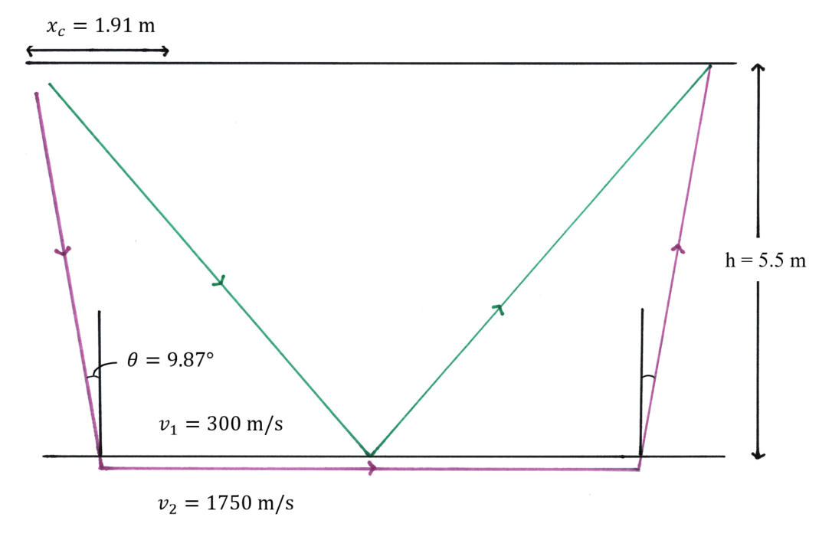

Figure 16 Cross-section based on common offset survey.

**Conclusion**

The results from the common shot survey indicate a 6.50-meter deep layer with a wave propagation velocity of 200 m/s and a velocity of 1900 m/s for the layer below. The common offset data were less clear, but resulted in similar numbers. While I was conducting the common offset survey, there was some construction nearby. Although I did my best to wait for any obvious construction noise to stop before hammering, there were smaller disruptions during some of the shots that appear to have overridden the signal.

**References**

1. Robinson, B. (2000). GEPH316 Seismic Data Processing. https://pages.mtu.edu/~ctyoung/ge4410/processing/Gathers.htm
2. Robinson, B., & Coruh, C. (1988). Refracted Seismic Waves and Earth Structure. In *Basic Exploration Geophysics* (pp. 42–44). John Wiley & Sons.